Whether, you’re young or old, married or single we need as much help as we can get. This year, we enter the “Village in Bloom” competition for the first time where we will be judged on how the village looks!

Minutes or five hours, all helps and makes a contribution. So why not come along to our meetings
Which are held at

………………………………………………………

Or you could join our weekly working parties details from Bridget 01977 553747

Or why not fill in your details below and hand them in to Princes Butchers or Valentines.

Your information will be held securely and not used outside the group.

Name

Address

Telephone

Email

Further information is available on our website
http:// allertonbywaterparishcouncil.co.uk and click on Allerton in Bloom on left hand side.

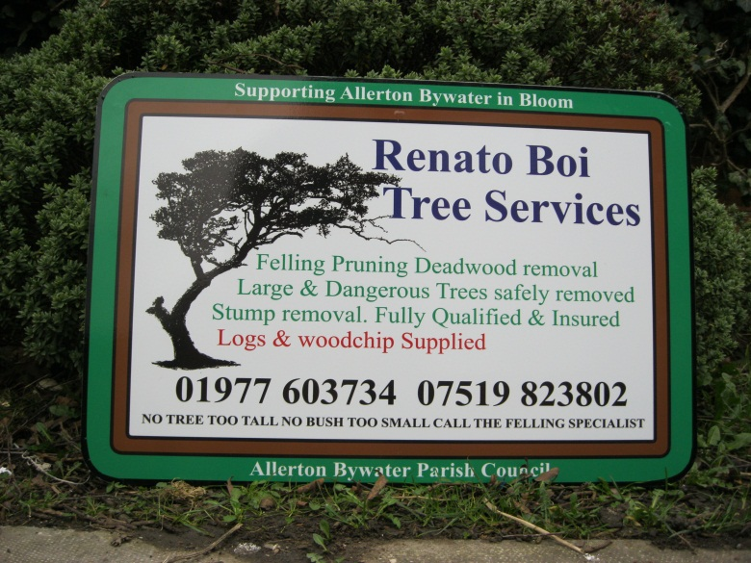

So if you want to get involved, find out a little bit more or you would like to make a financial contribution.

Please Contact: Bridget Mitchell

Chairperson Allerton in Bloom

Tele: 01977 553747

Come and
Join Us

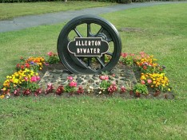

It all began back in 2009 when a group led by Bridget Mitchell decided to improve how St Mary’s graveyard, looked. Over grown and looking rather untidy the group work hard to make the church yard a much better and more respectful place.

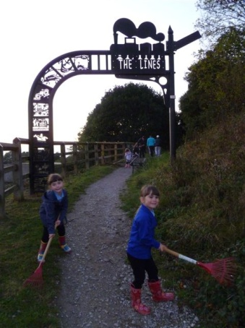
Inspired by the graveyard project the group decided to do similar things around the village, to make Allerton Bywater a much more pleasant place to live. Today, that still remains the key aim of the group and with the help of sponsors local to the village, we have made some real improvements.

Our team has grown a little and is supported by the Parish Council but we still need more helpers. It’s great to have children in our group and we would love more families to join us. Working in the team brings a feeling of community involvement and wouldn’t it be great to bring back some more of that community spirit, just like ‘in the old days’

You may have seen as you walk around the village some of the projects we have achieved so far and the impact they have made: the Pasture Hedge, or Tickle Cock Bridge below:
Before our work

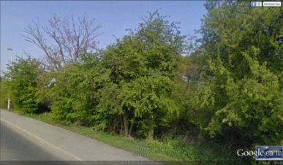

And After

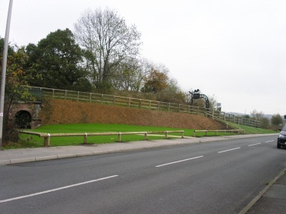

But we have not finished here, over the next
five years we aim to transform the village,
and we have a number of projects up our sleeve. But we need your help to make them
a success. Shortly, we will be starting two new projects that will involve a competition
for the Best Kept Pub/Business and the best garden on the bloom route.

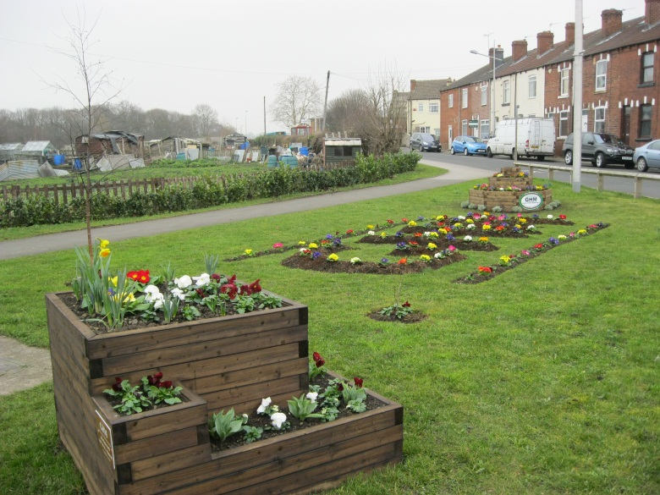
Display at Park Lane Roundabout by GHM Services. Allerton Bywater

As a new member in the team you will no
doubt have new ideas and a fresh pair of eyes on how we can all contribute to making our village a better place to live.

